Comviva’s Digital Evolution: A Journey towards Innovation
Digital Transformation refers to the process of adopting digital technology to an organization’s existing products, processes & strategies along with providing better customer experience. Those technologies often include Artificial Intelligence (AI), Internet of Things (IoT), Big analytics & automation. As the business world is ever evolving, digital transformation is a continuous journey rather than just a one-time event. It is a continuous evolution to innovate & improve.

Digital Transformation =/= Rip and Replace

Digital Transformation = Modification of existing digital technology

The BlueMarble Technique: Unlocking BSS Solutions
Communication Service Providers (CSPs) need a flexible BSS solution that fits their business needs providing great scalability & adaptability. Comviva’s BlueMarble is a solution for the same. BlueMarble is a BSS solution to enable businesses to transition from complex IT infrastructures to simple & agile operations. It enhances customer experience, provides faster 5G solutions along with rapid launch of new business models.

With BlueMarble, CSPs can iterate quickly, responding to industry triggers like M&A activities or launching new digital brands with ease. Based on IT systems, this solution provides modularity & agility in their innovative services.

BlueMarble helped our clients; Tier 1 operator in Mexico & Vodafone Ziggo to reach their business goals effectively. Firstly, we will look through the challenges followed by the solutions & benefits derived from adapting to those solutions. Let’s have a look at their journey to know how BlueMarble has created an impact.

The Five Pillars of Progress
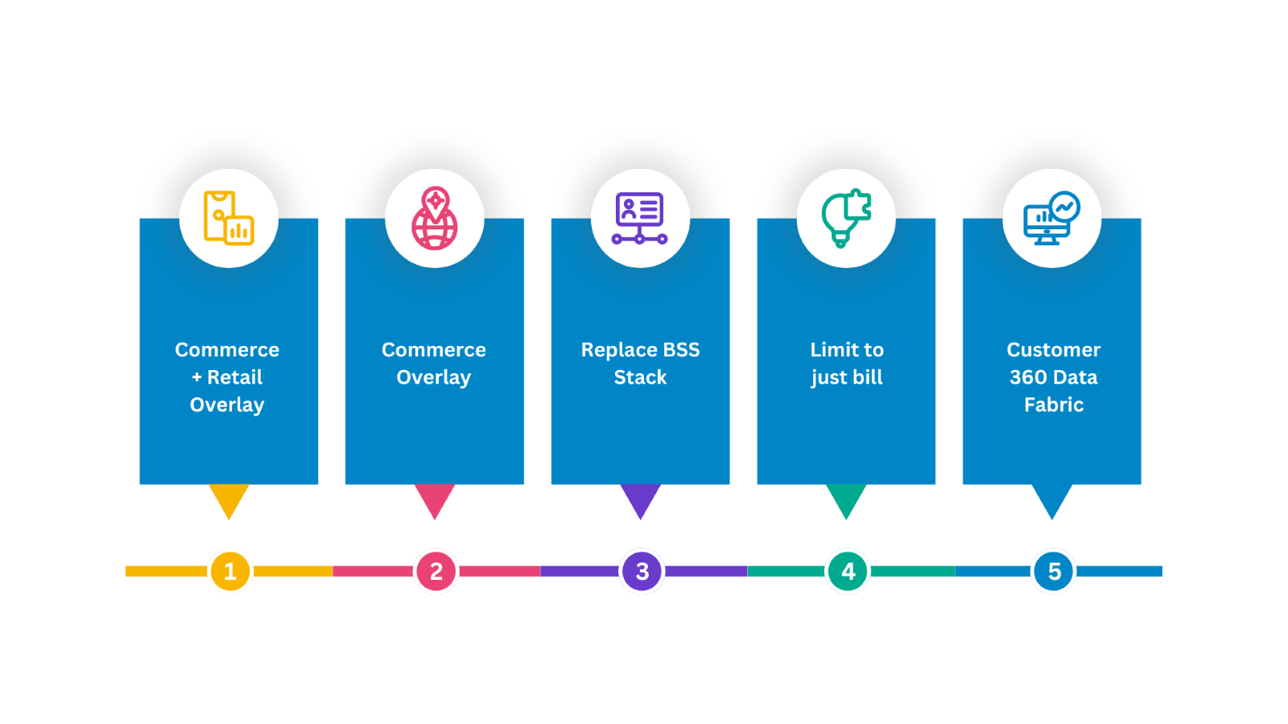

BlueMarble aims to revolutionize the IT driven systems to customer centric systems that increase personalized engagement & enhance customer experience. To stay in par with the continuous evolution, Comviva has adopted the Five-Pillar Approach
- Commerce + Retail Overlay
This deals with separating each phase of the customer’s journey & reducing retail operation costs. Decoupling the customer journey is a part of making the platform customer centric. This enables businesses to reach their goals, serve customers better & gain a competitive advantage.

It also deals with Retail Inventory Management from the Point of Sale including forward & reverse logistics. It integrates Enterprise Resource Planning, Data Warehouse, Warehouse Management Systems.

- Commerce Overlay
The second pillar deals with accelerating monetization of new technologies & reducing sales & service costs.
This is further divided into 2 Phases. The goals of the 1st phase include
- To create a federated product catalog which will enable a shorter time to market (TTM) & reduce the dependency on IT for product launches.
- Acquisition of B2C & basic commerce & order management functions.
- Catalog Integration with AMDOCS multi-access edge computing (MEC) FOR B2C
- Introduce Digital Experience Platform (DXP) for self-care channels
The goals of the 2nd phase are as follows
- Configure, Price, Quote (CPQ) & Embed CPQ Package in salesforce for B2B along with acquisition for B2B
- Enhanced features of commerce & order management
- Catalog Integration with AMDOCS multi-access edge computing (MEC) FOR B2C
- Omni-Channel, sell any product, bundling and partner offers

- Replace BSS Stack
This pillar deals with 80% cost reduction of BSS Total Cost Ownership (TCO) which means the total cost of the network for its entire service life & End to End BSS stack development

- Limit to just Bill
This pillar aims to eliminate Bill & Full decoupling of customer facing operational capabilities.

- Customer 360 data Fabric
The last pillar deals with 10x reduction of system of records calls with data fabric & Lowering cloud operational costs with transactions and stability

BlueMarble aims to reduce the Average Handling Time (AHT) and order errors by 40% each. This will ensure quick delivery along with rapid product launches from days to hours.

How to Revolutionize Retail with BlueMarble Solutions?
It is categorized in two ways, Forward Logistics Serialization & Reverse Logistics Serialization. Original Equipment Manufacturers transfer the assets to the distribution centers who then pass it to the retail stores. Customers get their assets from these retail stores. If the customers find any faults in the assets, they send it to the retail stores who then send it to the repair distribution centers.

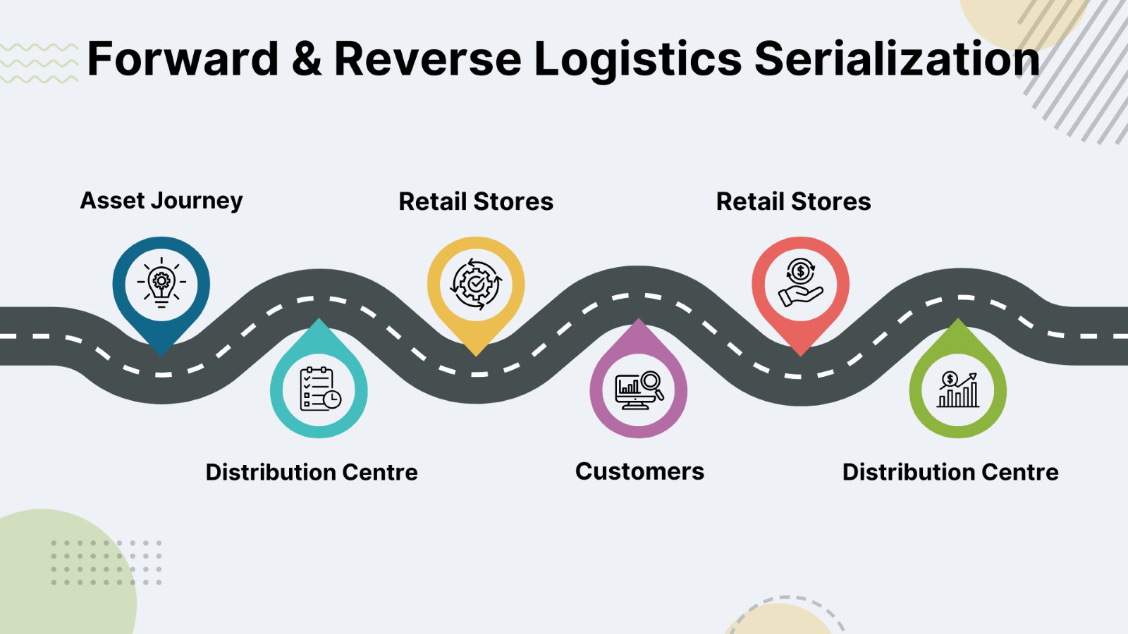

Case 1
The client, which is a Tier 1 operator in Mexico, has about 30 million subscribers & deals with products & services such as Postpaid Mobile, Prepaid Mobile & Mobile Internet. Having a strength of about 20,000 employees, this telecom company deals in about 700 retail stores, call centers and digital media.
For this case, we will highlight how Comviva solved the challenges using the Commerce + Retail Overlay approach, which is about providing better customer experience & reducing retail operation costs.

Challenges waiting to unfold:
The client managed multiple product catalogs managed by a third party CRM. The order management systems were manually configured for digital channels. Due to this the client faced the problem of inconsistency across the sales workforce.
The client faced challenges of a broken customer journey & high order fall outs due to heterogeneous & complex B/OSS stacks for Prepaid, Postpaid & Enterprise lines of businesses. Due to lack of integrated inventory visibility & real-time tracking of retail store inventory, forward & reverse logistics, high operating expenses were incurred with each channel demanding its own individual integration of efforts and complexities.

Game-changing solutions:
The project was carried on in two stages. Firstly, processes were streamlined for unified sales & customer experience & the next step was to develop an app to provide a flawless customer experience.
To overcome the challenge of a broken customer journey, BlueMarble used a Centralized digital enablement layer to connect prepaid, postpaid & enterprise lines of businesses across customer touchpoints. The Comviva Catalog, which is an order & retail inventory management solution, enabled real-time tracking of retail inventory across the life cycle & empowered agents with an integrated view across all stores & tower sites.
The app curated by BlueMarble provided a seamless experience making it easier for customers to navigate & find the solutions to their problems through it.

Advantages that add value:
BlueMarble helped the client to save integration costs by 50% by building a centralized digital enablement layer. After adopting BlueMarble retail, the client received 300+ bulk orders each day resulting in 6600 orders per month.
It also improved the number of new customers visiting the app by 50% coupled with enhancement of customer experience displayed through mobile app ratings. BlueMarble implemented Proof of Delivery (PoD) to avoid delivery side mismatch issues & prevented up to 5000 transit loss/ misreporting cases significantly uplifting revenue across all channels.

Navigating Service Channels for Seamless Integration
For sales, BlueMarble used channels like the contact center, Point of Sale, ecommerce Direct Sales & BBRs (Bottleneck Bandwidth and Round-trip propagation time). They provided web services through Oracle, WMS & DHL. Comviva developed an app powered by MobiLytix™ Digital for productized integration of inventory management. MobiLytix™ also provided a comprehensive user database to analyze customer usage, behavior and preferences insights which significantly improved the customer experience.

BlueMarble's Success: Strategies for Goal Achievement
Pain Points | Use Case | Capabilities
1. Inventory Leakage due to missed tracking | Purchase Order Digitization | - Digitization of entire inventory  - Digitization of stock inventory & takeout
2. Faulty equipment which was not compatible with existing OEM equipment | Forward & Reverse Logistics | - Planning of last mile delivery with onboarded logistics vendors  - Checking availability & compatibility of ordered items  - Tracking every serial end to end in transition
3. Losses at stores due to equipment's not being maintained | Real Time Audit & Reconciliation | - Development of the Mobile App  - On the spot Reconciliation  - Digitalized treatment of write-offs

Difference between Legacy & Transformed BSS in the case of our Tier 1 Operator.
1. 3 separate heterogenous complex B/OSS stacks for prepaid, postpaid & enterprise | Centralized digital enablement layer
2. Broken Customer Journey | Unified customer experience
3. Multiple agents' interfaces | Centralized & single front end for agents
4. Each channel had its own agent integration & complexities | Simplified connection to central BlueMarble Platform
5. Large amount of manual back-office processes | Automated E2E process from lead to cash

Solution Overview – A closer look at BlueMarble's Impact on Digital Experience
BlueMarble will help to achieve an omni-channel experience that will enable the users to experience seamless services across all channels such as online or offline
BlueMarble aims to enhance Sales Rep experience by enabling unified front-end experience
It offers centralized Product Catalogue & Configure, Price & Quote (CPQ) functionality across all challenges
Unified Order Management from channels to Southbound systems.
Each customer knows what he can expect from a particular channel. Keeping this in mind, BlueMarble provides Consistent Customer Experience across all channels
BlueMarble enables Multi-play Commerce which means that the product bundles across three channels; Mobile + Entertainment + IOT
Telco specific built into product. Cloud-Native micro services built
Blue Marble exposes TM Forum aligned 170+ Business Services for Channels
Proven integration with Amdocs, Matrixx, Oracle, SFDC, Adobe Experience Manager.
Automatic product catalog import, customer creation, order creation and orchestration which reduces order processing errors & delays in fulfilment
Blue Marble will be an overlay federation layer, that ensures channels immune to transitions/changes in southbound
Channel Integration refers to the integration of monitoring, business analytics & push notifications into a single app named Magento through dealers, telesales, stores & customer care. Salesforce integration means connecting salesforce with the other systems or applications used within the organization. This enables better coordination, automation, and utilization of data across various departments and functions.
BlueMarble helped our client with its salesforce integration in two ways, catalog sync & quote sync. Catalog sync consists of a catalog manager who receives the catalog updates about various events like product offer price created or product offer created. The catalog manager then forwards these details to the other sales force departments. Quote sync includes a sales agent who gives the opportunity of creating an event to its salesforce.

Case 2
Vodafone Ziggo
VodafoneZiggo, a Dutch company, formed in 2017 provides telecommunications, internet & television services. The merger of Vodafone & Ziggo was specifically carried out to combine Vodafone's mobile network with Ziggo’s fixed line network thus providing a combination of services like mobile, fixed-line internet, television, and landline telephone services to its customers.
Ziggo provides 9.7 million services to its customers with nearly 4 million televisions, over 3 million internet and 2.5 million fixed and mobile telephone services subscribers.

Challenges waiting to unfold:
VodafoneZiggo faced the challenges of a long trailing twelve months (TTM) for new products launch due to inflexible back-end systems. They failed to create a consistent customer experience across all touch points which resulted in high revenue leakage & poor sales conversion.
They also faced the challenge of managing several legacy BSS while improving customer experience. They wanted to build a unified, omni-channel & cloud native BSS solution to provide their huge customer base with a variety of services.

Game-changing solutions:
BlueMarble constructed a unified omni-channel solution that used application programming interface (API) & federated commercial product catalog with integration into business back-end. It consolidated UI & workflows across all channels with a direct & deep integration to order & logistics back-end systems with BlueMarble Commerce.
With the help of Comviva’s BlueMarble software, a cloud native BSS called One Sales Foundation was created to offer seamless services.

Advantages that add value:
The One Sales Foundation showcased significant improvements in sales experiences as 70% of the customer interactions were digital. The BlueMarble solution, which was deployed in just 6 months in up to 250 stores generated a new mobile product proposition in less than 4 hours & reduced the average handling time (AHT) in stores by 40%. All this reduced the training time from 4 days to 4 hours & enhanced customer satisfaction score & retention.
Ulrin Irnich from VodafoneZiggo says, ‘‘We are connecting…all digital channels to the same basket so that we have a seamless experience for our customers regardless of which kind of journey they are starting or where.’’
Processing the change was a challenge for the employees but as they adapted to the tools they saw a significant increase in sales. Also, the company saw an increase in the Net Promoter score that measures customer satisfaction.
Using cloud-native systems to create streamlined customer journeys also made it simple for national operators within the Vodafone Group to share tools and approaches that work.

Solution Overview – A closer look at BlueMarble's Impact on Digital Experience
BlueMarble Commerce is an omni-channel solution providing consolidated user interface across all channels, brands & products for sales. It federated commercial product catalog with integration into business backend & extension towards multi-play delivery & merger. It also initiated direct & deep integration with the order & logistic back-end systems.
BlueMarble used Open Digital Architecture which creates digital ecosystems in telecom. It replaced traditional BSS offering to cloud native software components that enabled communication service providers (CSP) to invest in new & differentiated IT services.
Vodafone used digital channels like the web & app along with assisted channels like the store & telesales & 3rd party service providers like the dealers.
Vodafone's application providing interface gateway included product catalog, commerce & order management. It used software like Netcracker, Amdocs & Oracle.
Mobile BSS stack includes Amdocs CES suite which consists of Ordering Management Systems (OMS), Master Enterprise Catalog (MES), Customer Relationship Management (CRM). These modules are accessed over Amdocs BSL layer or the multi-channel self-service.

Conclusion
Comviva aims to bring the world closer through digital transformation. It focuses on empowering telecom operators, financial institutions, & other service providers to offer innovative & convenient financial services to their customers by providing digital solutions to products such as Customer Relationship Management (CRM), Billing, Order Management, CPQ software, etc.
Comviva stands among the leaders in mobility solutions offering a wide range of services to around a billion users worldwide. These innovative digital solutions provide flexibility, greater choice & improved customer experience altogether. Over 130 communication service providers across 90+ countries are deploying them, changing the world!

